**FocusCounter Instructions**

**Installation:**

1. System requirements: 32-bit PC running Windows XP (will run on Windows 7, but some buttons will be hidden).
2. Program requires the correct version of MATLAB to run. This can be either the full paid version (R2006a) or a free standalone version (MCR 7.5). MCR 7.5 installer is available free from various web sources (or contact David Bates).

**Image files:**

* FocusCounter will only work with 8-bit grayscale TIFF images.
* Prepare image folder: Folder should contain pairs of files corresponding to phase and fluorescence images of the same field of cells. Only one fluorescence channel can be analyzed at a time (may repeat analysis using second fluorescence channel). The phase contrast image filename must contain the string “Brightfield” (exactly as shown), and the corresponding fluorescence image filename must have the exact string in front of the “Brightfield” string. Example:

Strain1226_001_Brightfield.TIF

Strain1226_001_GFP.TIF

Strain1226_002_Brightfield.TIF

Strain1226_002_GFP.TIF

Strain1226_003_Brightfield.TIF

Strain1226_003_GFP.TIF

* Phase contrast and fluorescence images must be pre-aligned (zero pixel shift) before analysis.

**Running the program:**

1. Start FocusCounter by clicking **Experiment Processor.exe**. A command prompt window and a graphical user interface (GUI) window will open (older systems take several minutes to load).
2. On the ‘Directory_GUI’ window, click **Directory** button and select image folder.
3. Click **Run** button. After initial image processing a new window will open, called ‘Batch_Threshold_GUI’. This may take several minutes depending on number of images, quality of phase contrast and number of cells per image.
4. Set thresholding for all phase contrast and fluorescence images. Increase or decrease ‘Image Threshold’ by changing the value in the upper box. Use **Grayscale Thresholding** for most image types. Initial values are automatically set according to each image grey value histogram. Phase contrast: adjust threshold such that most cells are white, most of the background is black, and non-cell objects are green. After phase image is thresholded, click **Next Channel** to threshold 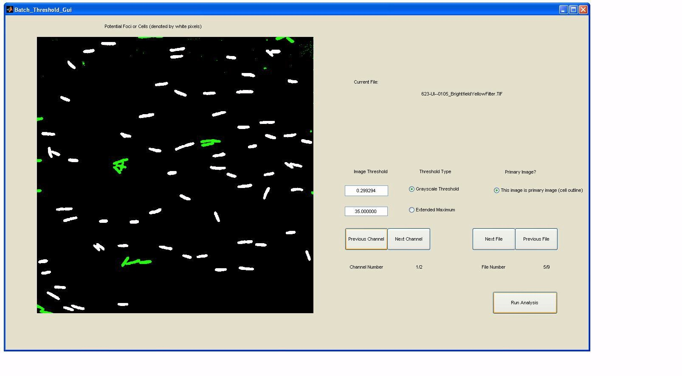fluorescence image. Here, you want to have a mostly black background with solid (not granular) white objects corresponding to foci. Repeat for each image pair by selecting **Next File**. Note: the goal is to reduce false positives here. Excessive false positives (white objects that are not cells or foci) will greatly delay processing time. Missed foci (false negatives) can be easily added in subsequent steps. Missed cells, especially when many cells are close together, are a limitation of the program and can only be avoided by image well-dispersed and dilute cell samples.

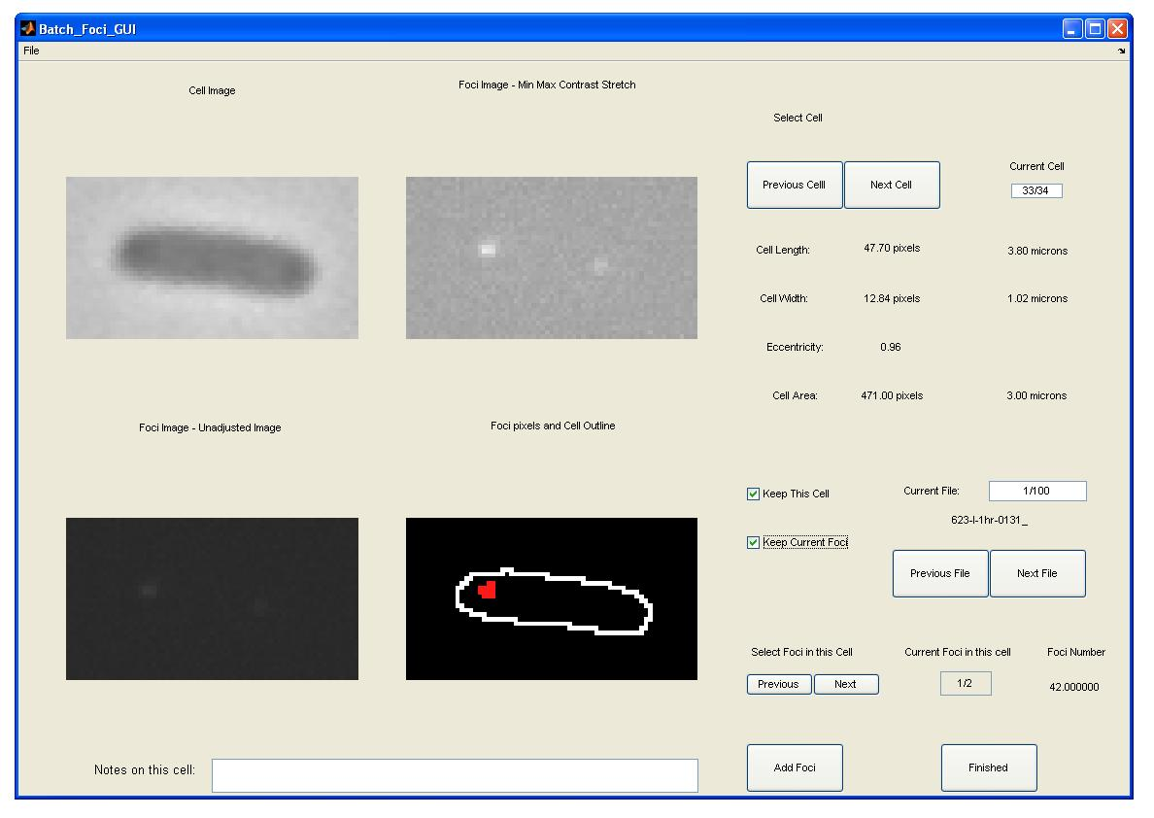

1. After all channels of all files have been thresholded, click **Run Analysis** button. A new window will open, ‘Batch_Foci_GUI’, in which focus assignments will be checked cell-by-cell. Phase contrast (left images) and fluorescence (right images) regions for each cell will be shown. Upper images are auto-contrasted (to aid in visualizing foci), lower images are unadjusted and show cell and focus regions in color. Visually confirm all foci in each cell by cycling through foci by clicking **Previous** or **Next** buttons under ‘Select Foci in this Cell’. To add a focus that was missed by thresholding, click **Add Foci** button, hold crosshair cursor over focus on upper right image and click once. Repeat for additional missing foci. To delete a focus, uncheck **Keep Current Foci** box, while focus to be removed is currently selected. After all foci are correctly assigned, advance to the next cell by clicking **Next Cell** button. Omit cells by unchecking **Keep This Cell** box. If foci are present outside the cell boundary, phase and fluorescence channels were not aligned, or, phase thresholding was set too high reducing size of cells.
2. After all cells are checked, click the **Finished** button. For each contrast image, a jpeg file will be created with showing cell outline overlays (cells are numbered from upper left to lower right). An Excel spreadsheet will be created listing (B) percent cells with 0,1,2,>2 foci, (C) the cell number, (D) image name, (E) phase thresholding method, (F) phase threshold value, (I) cell center x,y coordinates, (J) cell area, (K) cell length, (L) cell width, (M) Eccentricity = degree of deviation from a circle; used to define rod-shaped bacteria objects, (N) orientation of cell’s long axis on image, (O) foci channel name, (P) Foci thresholding method, (Q) foci threshold value, (R) number of foci per cell, (S) inter-focus distance, (U-V) user-added foci denotation, (AC-AF) focus intensities, (AG-AJ) focus x coordinates, (AK-AN) focus y coordinates, (AO-AR) focus x,y coordinates, (AS) mean fluorescence signal inside cell. Units of measurements: lengths are in microns (12.8 pixels/micron), coordinates are in pixels, signal intensities are in 8-bit grey values (0-255).